**Assignment No 4**

**Roll No 27**

**1) Write a program to create login page.**

**Default.aspx**

<%@ Page Language="C#" AutoEventWireup="true" CodeFile="Default.aspx.cs" Inherits="_Default" %>

<!DOCTYPE html>

<html xmlns="http://www.w3.org/1999/xhtml">

<head runat="server">

<title></title>

</head>

<body>

<form id="form1" runat="server">

<div>

<asp:Label ID="Label1" runat="server" Text="User Name"></asp:Label>

<asp:TextBox ID="TextBox1" runat="server"></asp:TextBox>

<asp:Label ID="Label2" runat="server" Text="Password"></asp:Label>

<asp:TextBox ID="TextBox2" runat="server" TextMode="Password"></asp:TextBox>

<p>

<asp:Button ID="Button1" runat="server" onclick="Button1_Click" Text="Submit" />

</p>

<p>

<asp:Label ID="Label3" runat="server" Text="Label"></asp:Label>

</p>

</div>

</form>

</body>

</html>

**Defualt.aspx.cs**

using System;

using System.Collections.Generic;

using System.Linq;

using System.Web;

using System.Web.UI;

using System.Web.UI.WebControls;

public partial class _Default : System.Web.UI.Page

{

protected void Page_Load(object sender, EventArgs e)

{

}

protected void Button1_Click(object sender, EventArgs e)

{

Label3.Text = "LOGIN SUCCESSFULLY";

}

}

**Output**

1. **Before Login**

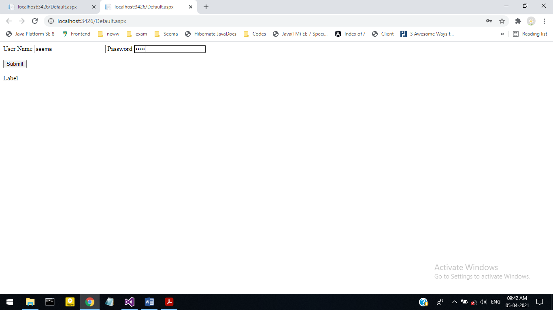

1. **After Login**

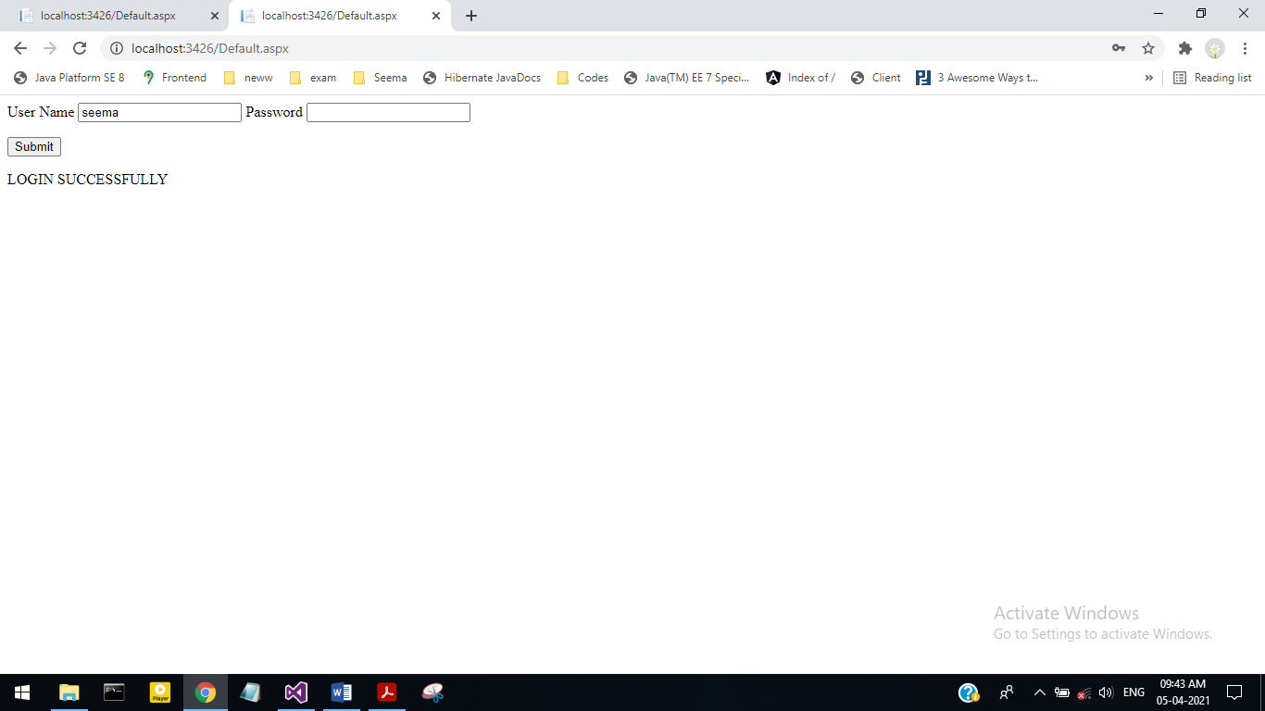

**Roll No 27**

**2) Write a program to addition of two numbers.**

**Addition.aspx**

<%@ Page Language="C#" AutoEventWireup="true" CodeFile="Addition.aspx.cs" Inherits="Addition" %>

<!DOCTYPE html>

<html xmlns="http://www.w3.org/1999/xhtml">

<head runat="server">

<title></title>

</head>

<body>

<form id="form1" runat="server">

<div>

<asp:Label ID="Label1" runat="server" Text="Enter A"></asp:Label>

<asp:TextBox ID="TextBox1" runat="server" ontextchanged="TextBox1_TextChanged"></asp:TextBox>

<br />

<asp:Label ID="Label2" runat="server" Text="Enter B"></asp:Label>

<asp:TextBox ID="TextBox2" runat="server"></asp:TextBox>

<br />

<asp:Button ID="Button1" runat="server" onclientclick="Button Click"

Text="Addition" OnClick="Button1_Click" />

<br />

<asp:Label ID="Label3" runat="server" Text="Addition"></asp:Label>

<asp:TextBox ID="TextBox3" runat="server" OnTextChanged="TextBox3_TextChanged"></asp:TextBox>

</div>

</form>

</body>

</html>

**Addition.aspx.cs**

using System;

using System.Collections.Generic;

using System.Linq;

using System.Web;

using System.Web.UI;

using System.Web.UI.WebControls;

public partial class Addition : System.Web.UI.Page

{

protected void Page_Load(object sender, EventArgs e)

{

}

protected void TextBox3_TextChanged(object sender, EventArgs e)

{

}

protected void TextBox1_TextChanged(object sender, EventArgs e)

{

int a = Convert.ToInt32(TextBox1.Text);

int b = Convert.ToInt32(TextBox2.Text);

int add = (a + b);

TextBox3.Text = add.ToString();

}

protected void Button1_Click(object sender, EventArgs e)

{

}

}

**Output**

1. **Starting Page**

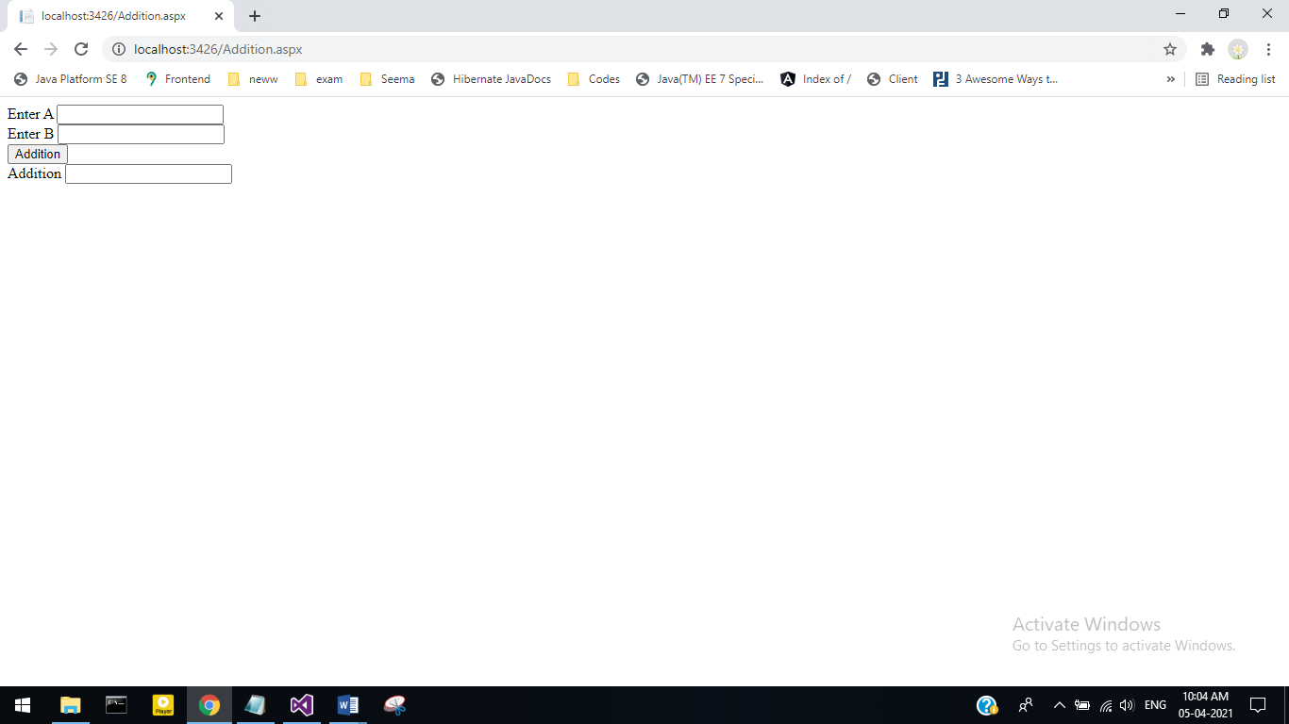

1. **After clicking addition**

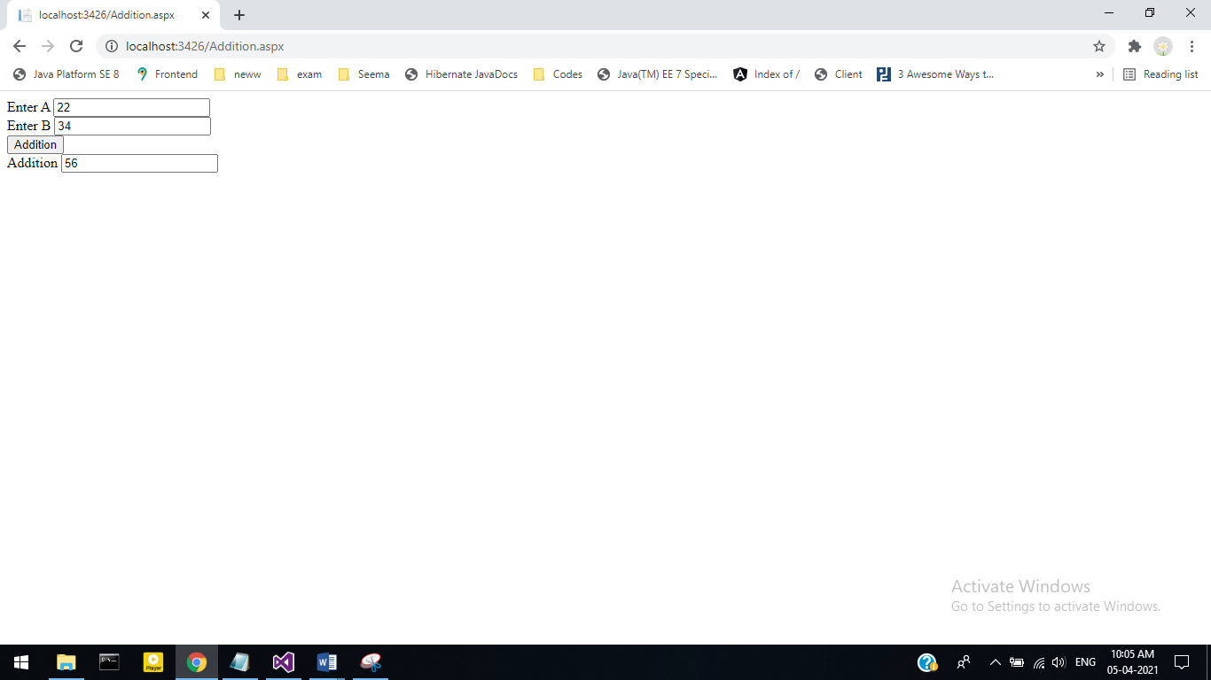

**Roll No 27**

**3) Write a program to demonstrate the Button Control & Hidden Field.**

**Default2.aspx**

<%@ Page Language="C#" AutoEventWireup="true" CodeFile="Default2.aspx.cs" Inherits="Default2" %>

<!DOCTYPE html>

<html xmlns="http://www.w3.org/1999/xhtml">

<head runat="server">

<title></title>

</head>

<body>

<form id="form1" runat="server">

<div>

<div>

<asp:Label ID="Label1" runat="server" Font-Bold="True" Font-Underline="True"

Text="Button control example showing text on button click event"></asp:Label>

</div>

<br />

<asp:Button ID="Button1" runat="server" Font-Bold="True"

onclick="Button1_Click" onclientclick="Button1"

Text="Click Me,I will welcome You !!!" />

<br />

<br />

<asp:Label ID="Label2" runat="server" Text="Label"></asp:Label>

<br />

<br />

<asp:Label ID="Label3" runat="server" Font-Bold="True" Font-Underline="True"

Text="Field Control Showing value on Button click"></asp:Label>

<br />

<br />

<asp:Button ID="Button2" runat="server" Font-Bold="True"

onclick="Button2_Click" onclientclick="Button2" Text="Click Me!!" />

<br />

<br />

<asp:Label ID="Label4" runat="server"></asp:Label>

<br />

<br />

<asp:HiddenField ID="HiddenField1" runat="server" />

<br />

</div>

</form>

</body>

</html>

**Default2.aspx.cs**

using System;

using System.Collections.Generic;

using System.Linq;

using System.Web;

using System.Web.UI;

using System.Web.UI.WebControls;

public partial class Default2 : System.Web.UI.Page

{

protected void Page_Load(object sender, EventArgs e)

{

HiddenField1.Value = "Welcome to the world of ASP.NET 4.0";

}

protected void Button1_Click(object sender, EventArgs e)

{

Label2.Text = "Welcome to the world of ASP.NET 4.0";

}

protected void Button2_Click(object sender, EventArgs e)

{

Label4.Text = HiddenField1.Value;

}

}

**Output:-**

**1.Starting page-**

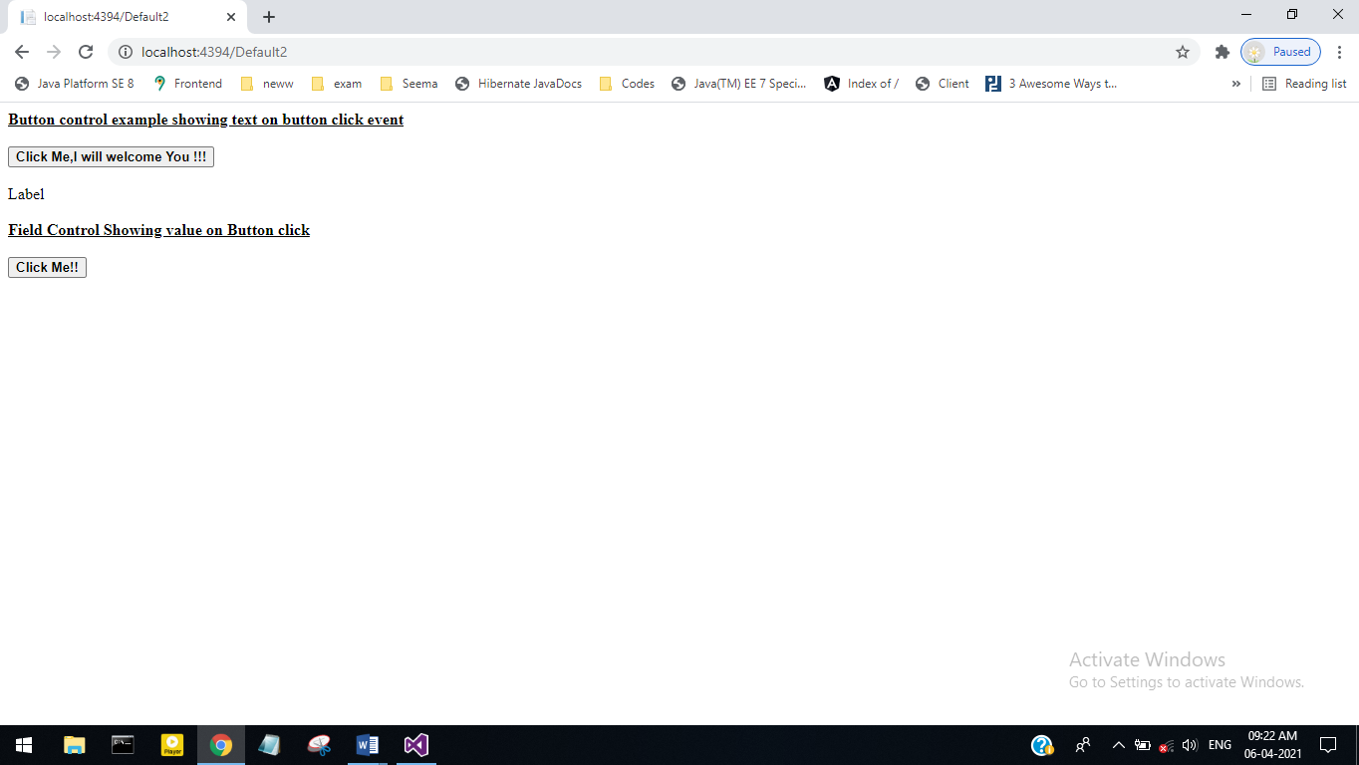

**2.After Clicking Click Me, I Will Welcome You!!!**

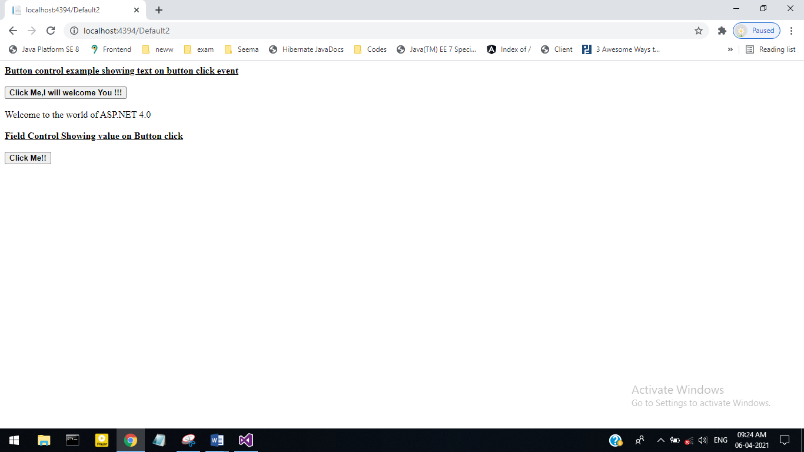

**3.After Clicking Click Me:-**

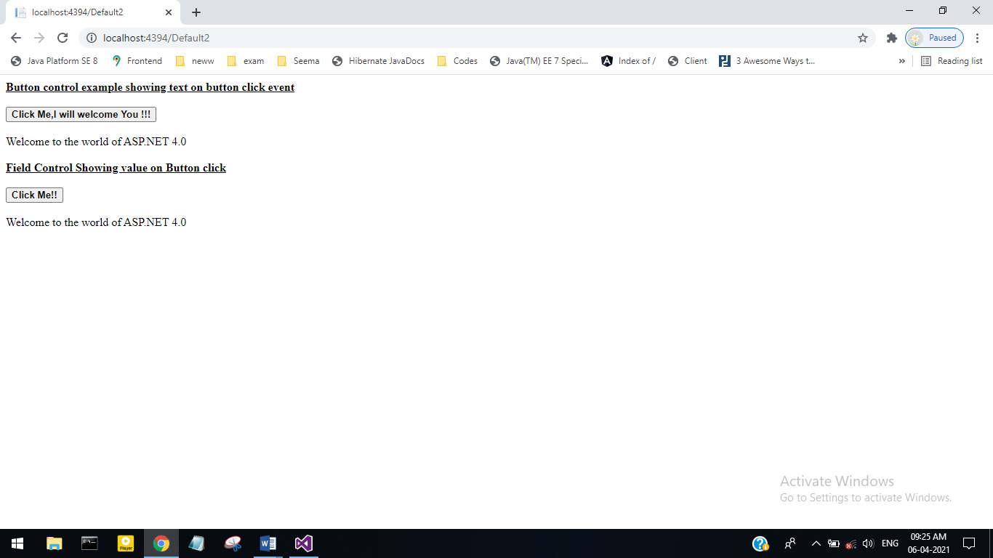

**Roll No 27**

**4) Write a program to demonstrate the Image Control & Image Button Control.**

**Default.aspx**

<%@ Page Language="C#" AutoEventWireup="true" CodeFile="Default3.aspx.cs" Inherits="Default3" %>

<!DOCTYPE html>

<html xmlns="http://www.w3.org/1999/xhtml">

<head runat="server">

<title></title>

</head>

<body>

<form id="form1" runat="server">

<div>

<asp:Label ID="Label1" runat="server" Font-Bold="True" Font-Underline="True"

Text="Image Control Example"></asp:Label>

<br />

<br />

<asp:Button ID="Button1" runat="server" BackColor="#999966" Font-Bold="True"

ForeColor="Blue" onclientclick="Button1"

Text="Click me to view the image!!" onclick="Button1_Click" />

<br />

<br />

<asp:Image ID="Image1" runat="server" BorderColor="#CC0099" Height="239px"

ToolTip="Image control example" Visible="False" ImageUrl="Images/download.jpg" />

<br />

<br />

<asp:Label ID="Label2" runat="server" Font-Bold="True" Font-Underline="True"

Text="ImageButton Control Example"></asp:Label>

<br />

<br />

<asp:Label ID="Label3" runat="server" BorderWidth="2px" Font-Italic="True"

ForeColor="#CC0000" Text="Click Anywhere on the ImageButton control Below"></asp:Label>

<br />

<br />

<asp:ImageButton ID="ImageButton1" runat="server" Height="205px"

onclick="ImageButton1_Click" onclientclick="&quot;ImageButton1"

Width="284px" ImageUrl="Images/download.jpg" />

<br />

<br />

<asp:Label ID="Label4" runat="server"

Text="You clicked on the ImageButton at following co-ordinates"

BorderColor="#FF66CC" BorderStyle="Outset"></asp:Label>

<br />

<asp:Label ID="Label5" runat="server" BackColor="#CC99FF"></asp:Label>

</div>

</form>

</body>

</html>

**Default.aspx.cs**

using System;

using System.Collections.Generic;

using System.Linq;

using System.Web;

using System.Web.UI;

using System.Web.UI.WebControls;

public partial class Default3 : System.Web.UI.Page

{

protected void Page_Load(object sender, EventArgs e)

{

}

protected void Button1_Click(object sender, EventArgs e)

{

Image1.Visible = true;

}

protected void ImageButton1_Click(object sender, ImageClickEventArgs e)

{

Label5.Text = e.X.ToString() + " , " + e.Y.ToString();

}

}

**Output**

**1.Starting Page :**

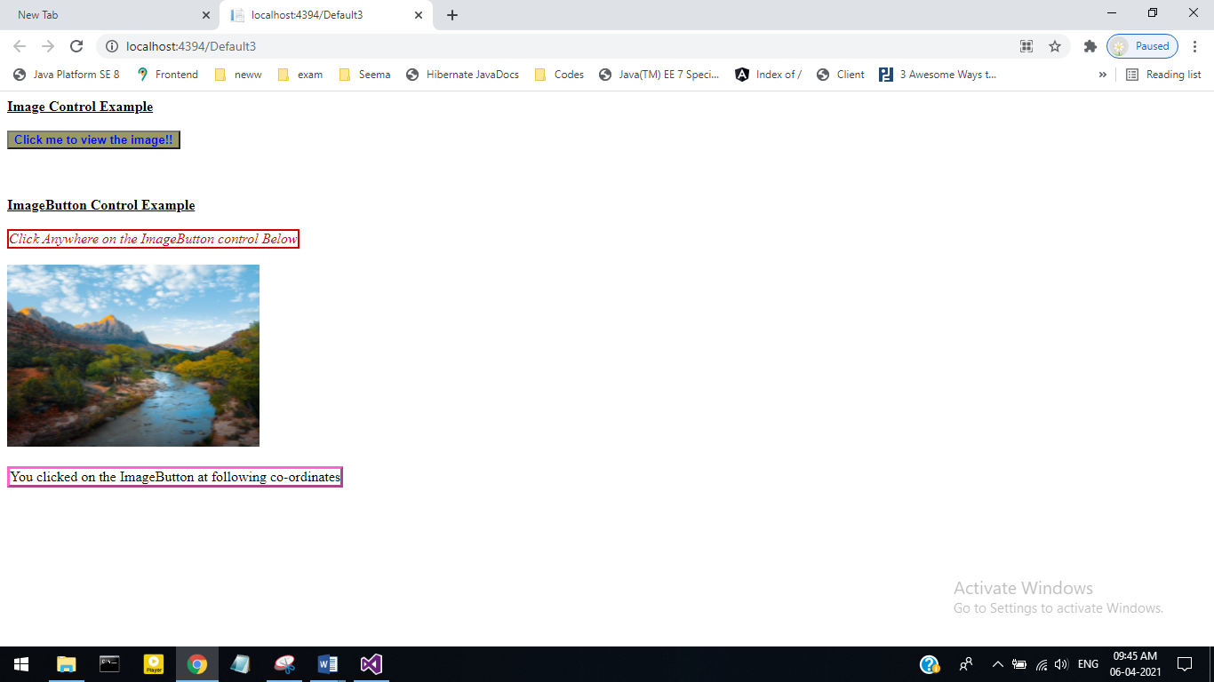

**2. After Clicking Click to view the image :**

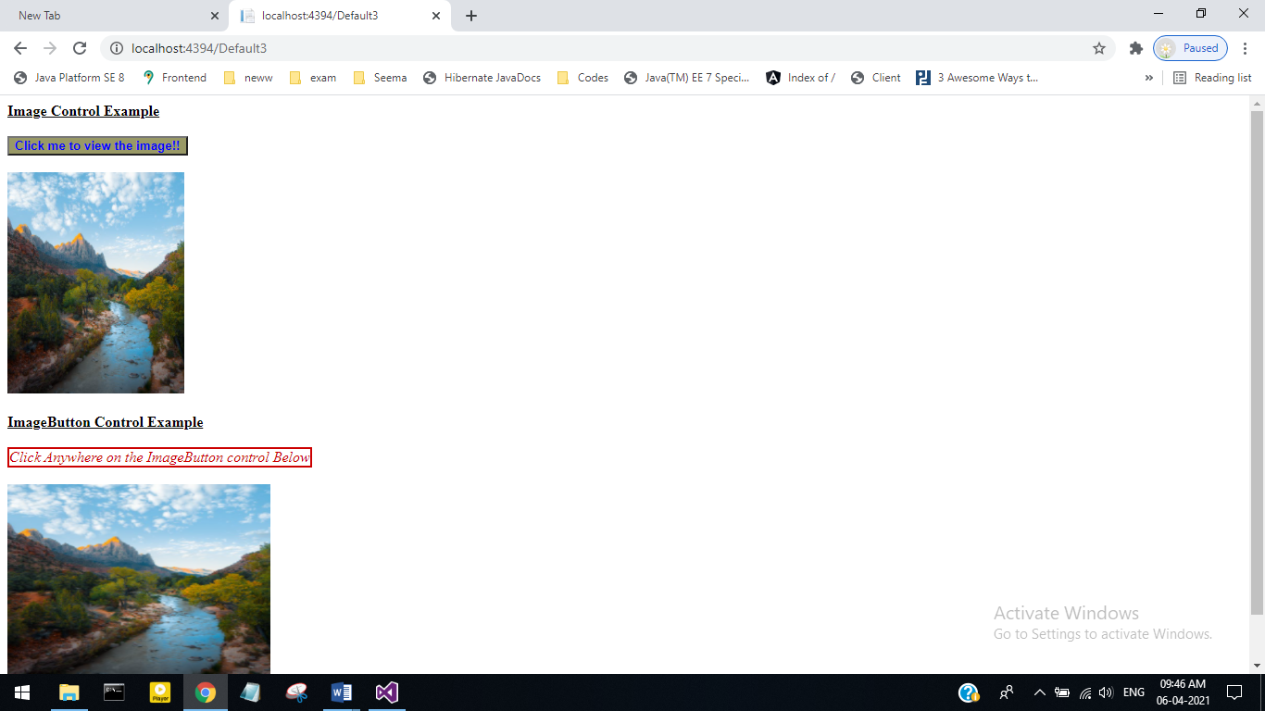

**3. After Clicking Image :**

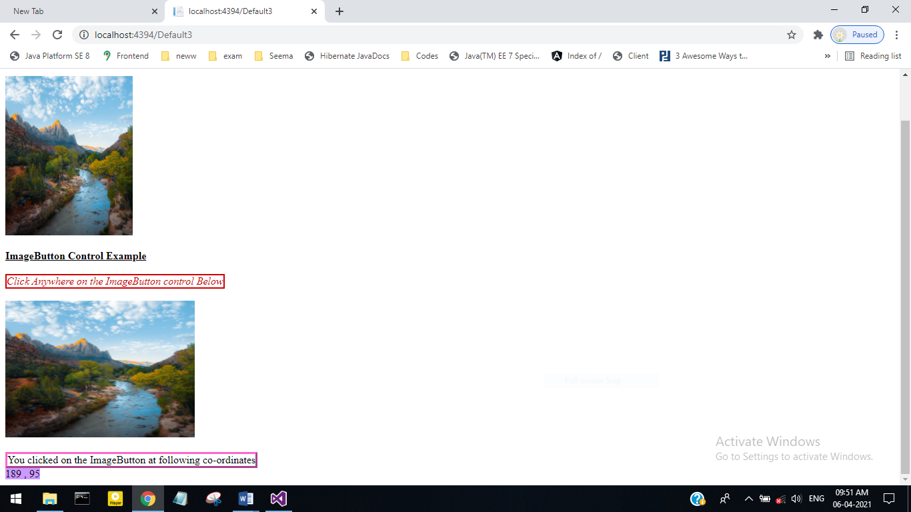

**Roll No 27**

**5) Write a program to demonstrate the Listbox Control & Dropdown list Control.**

Default.aspx-

<%@ Page Language="C#" AutoEventWireup="true" CodeFile="Default4.aspx.cs" Inherits="Default4" %>

<!DOCTYPE html>

<html xmlns="http://www.w3.org/1999/xhtml">

<head runat="server">

<title></title>

</head>

<body>

<form id="form1" runat="server">

<div>

<asp:DropDownList ID="DropDownList1" runat="server">

<asp:ListItem>Red</asp:ListItem>

<asp:ListItem>Yellow</asp:ListItem>

<asp:ListItem>Green</asp:ListItem>

<asp:ListItem>Blue</asp:ListItem>

<asp:ListItem>Cyan</asp:ListItem>

</asp:DropDownList>

<br />

<asp:Button ID="Button1" runat="server" onclick="Button1_Click"

Text="Select Color" />

<br />

<asp:Label ID="Label1" runat="server" Font-Bold="True" Font-Size="X-Large"

Text="Jaysingpur College Jaysingpur"></asp:Label>

<br />

<br />

<asp:ListBox ID="ListBox1" runat="server" OnSelectedIndexChanged="ListBox1_SelectedIndexChanged"></asp:ListBox>

</div>

</form>

</body>

</html>

**Default.aspx.cs-**

using System;

using System.Collections.Generic;

using System.Linq;

using System.Web;

using System.Web.UI;

using System.Web.UI.WebControls;

public partial class Default4 : System.Web.UI.Page

{

protected void Page_Load(object sender, EventArgs e)

{

}

protected void ListBox1_SelectedIndexChanged(object sender, EventArgs e)

{

}

protected void Button1_Click(object sender, EventArgs e)

{

string c = DropDownList1.SelectedValue.ToString();

ListBox1.Items.Add(c);

if (c == "Red")

Label1.ForeColor = System.Drawing.Color.Red;

else if (c == "Yellow")

Label1.ForeColor = System.Drawing.Color.Yellow;

else if (c == "Green")

Label1.ForeColor = System.Drawing.Color.Green;

else if (c == "Cyan")

Label1.ForeColor = System.Drawing.Color.Cyan;

else if (c == "Blue")

Label1.ForeColor = System.Drawing.Color.Blue;

else

Label1.ForeColor = System.Drawing.Color.Black;

}

}

**Output-**

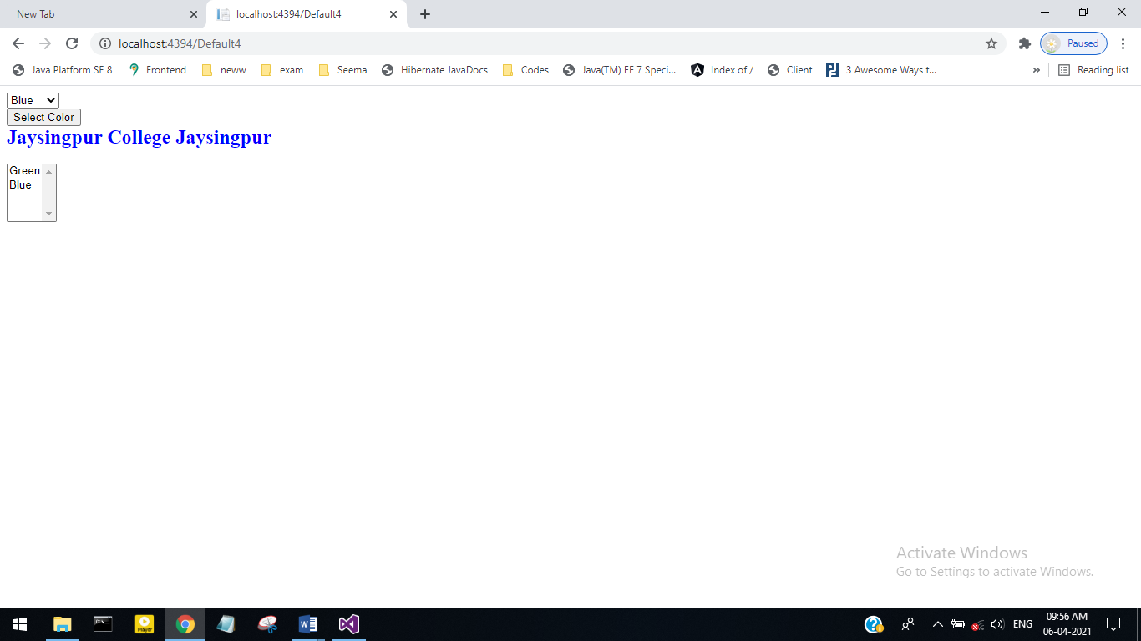

**Roll No 27**

**6) Write a program to demonstrate Hyperlink & Link Button Control.**

**Default.aspx**

<%@ Page Language="C#" AutoEventWireup="true" CodeFile="Default5.aspx.cs" Inherits="Default5" %>

<!DOCTYPE html>

<html xmlns="http://www.w3.org/1999/xhtml">

<head runat="server">

<title></title>

</head>

<body>

<form id="form1" runat="server">

<div>

<asp:Label ID="Label1" runat="server" Font-Bold="True" Font-Size="Medium"

Font-Underline="True" ForeColor="#FF66FF" Text="HyperLink control example"></asp:Label>

<br />

<br />

<asp:HyperLink ID="HyperLink1" runat="server" Font-Size="Small" ForeColor="Blue" Target="http://www.google.co.in" NavigateUrl="http:\\www.google.co.in">click me to move to the google website</asp:HyperLink>

<br />

<asp:Label ID="Label2" runat="server" font-bold="true" Font-Size="Medium" Font-Underline="true" ForeColor="Black" Text="LinkButton control example"></asp:Label>

<br />

<br />

<br />

<asp:LinkButton ID="LinkButton1" runat="server" BackColor="White" BorderColor="#00ccff" Font-Names="Tahoma" Font-Size="Small" ForeColor="#0000cc" OnClick="Linlbutton1_click" ToolTip="google website">LinkButton</asp:LinkButton>

</div>

</form>

</body>

</html>

**Default.aspx.cs**

using System;

using System.Collections.Generic;

using System.Linq;

using System.Web;

using System.Web.UI;

using System.Web.UI.WebControls;

public partial class Default5 : System.Web.UI.Page

{

protected void Page_Load(object sender, EventArgs e)

{

LinkButton1.Text = "click me to move to google website";

}

protected void Linlbutton1_click(object sender, EventArgs e)

{

Response.Redirect("http://www.google.co.in");

}

}

**Output:**

**1.Starting page-**

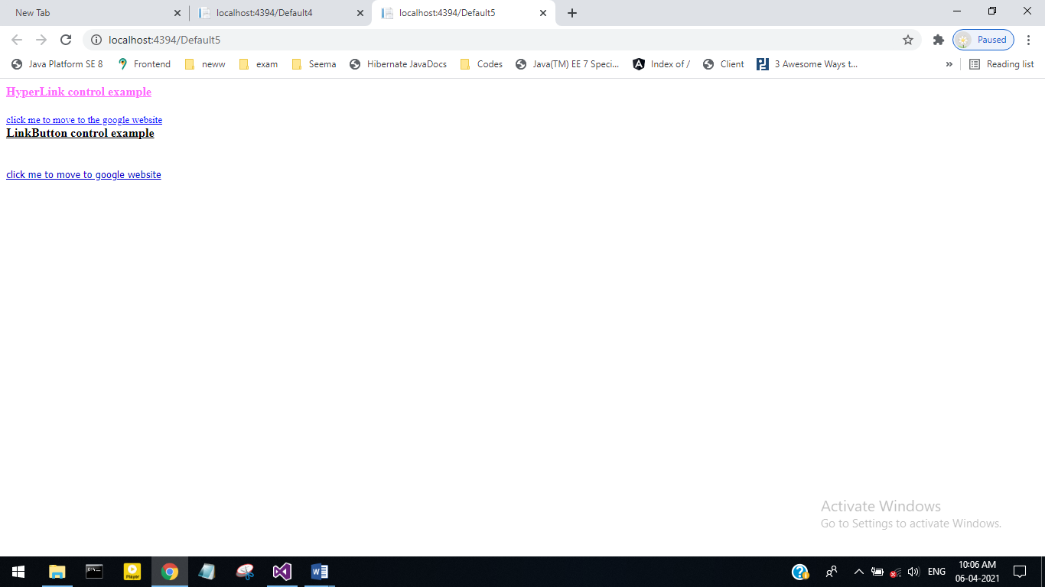

**2.After Cliking click me to move to the google website :-**

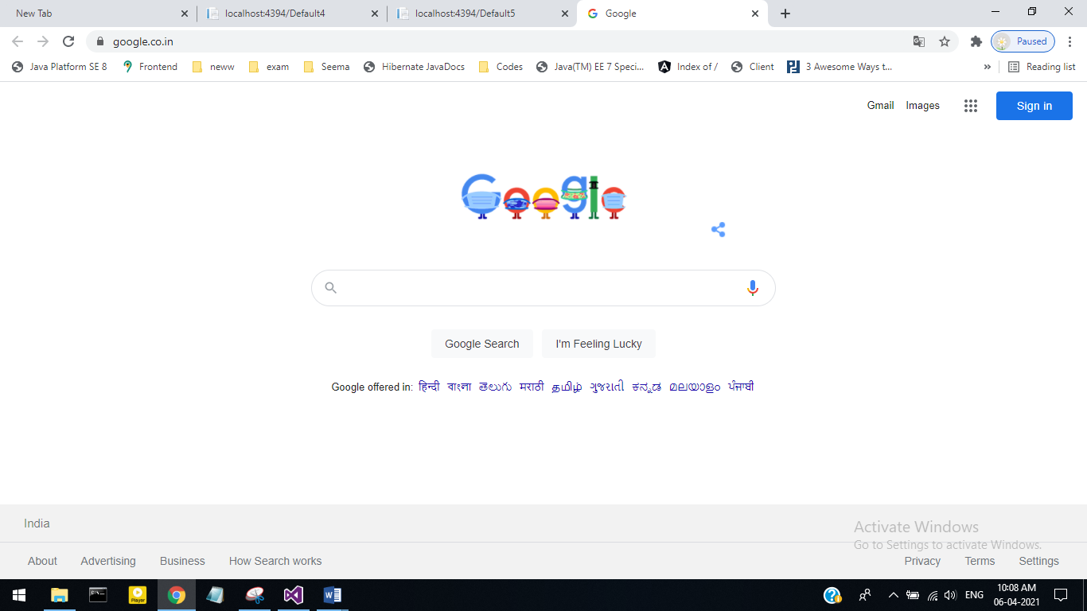

**3. After Clicking click me to move to google website:-**

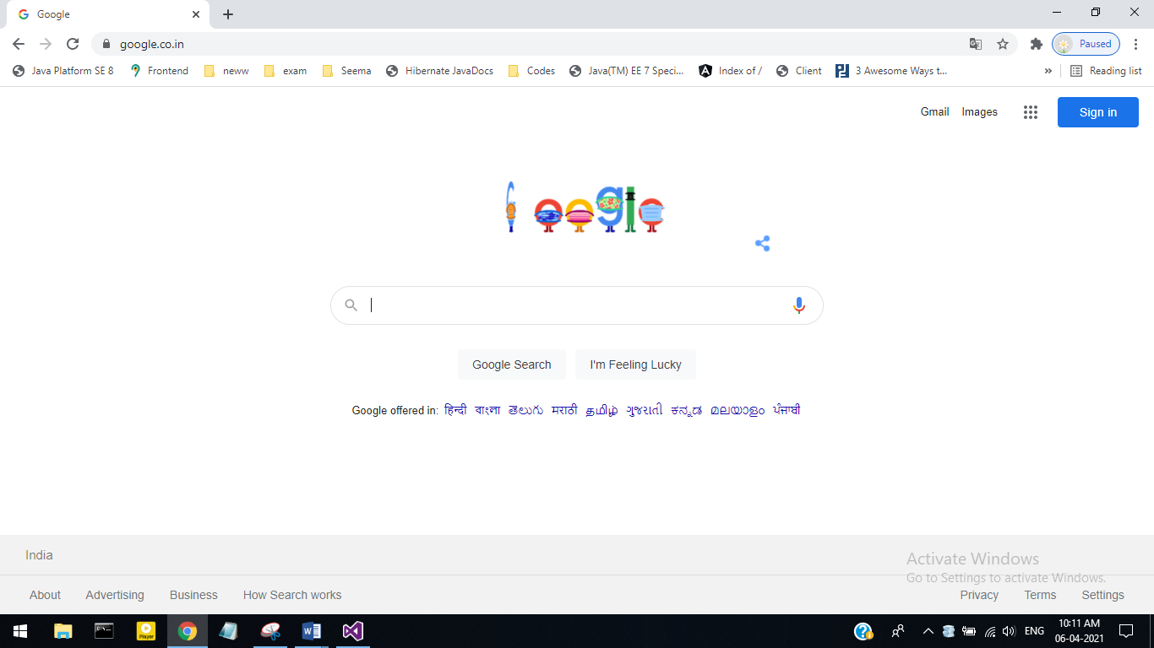

**Roll No 27**

**7) Write a program to Check Box & Radio Button & Pannel.**

**Default.aspx-**

<%@ Page Language="C#" AutoEventWireup="true" CodeFile="Default6.aspx.cs" Inherits="Default6" %>

<!DOCTYPE html>

<html xmlns="http://www.w3.org/1999/xhtml">

<head runat="server">

<title></title>

</head>

<body>

<form id="form1" runat="server">

<div>

<asp:Label ID="Label1" runat="server" Font-Bold="True" Font-Size="Medium"

Font-Underline="True" Text="Check Box Example"></asp:Label>

<br />

<br />

<asp:Label ID="Label2" runat="server" Font-Size="Small" ForeColor="#FF33CC"

Text="Which of these cars you own"></asp:Label>

<br />

<br />

<asp:CheckBox ID="CheckBox1" runat="server" AutoPostBack="True"

Font-Size="Small" oncheckedchanged="CheckBox1_CheckedChanged1"

Text="Maruti Zen" />

<br />

<asp:CheckBox ID="CheckBox2" runat="server" AutoPostBack="True"

Font-Size="Small" oncheckedchanged="CheckBox2_CheckedChanged1"

Text="Honda City" />

<br />

<asp:CheckBox ID="CheckBox3" runat="server" AutoPostBack="True"

Font-Size="Small" oncheckedchanged="CheckBox3_CheckedChanged1"

Text="Toyata" />

<br />

<asp:ListBox ID="ListBox1" runat="server" OnSelectedIndexChanged="ListBox1_SelectedIndexChanged"></asp:ListBox>

<br />

<br />

<asp:Label ID="Label3" runat="server" Font-Bold="True" Font-Size="Medium"

Font-Underline="True" Text="Radio Button Control Example"></asp:Label>

<br />

<br />

<asp:Label ID="Label4" runat="server" Font-Size="Small" ForeColor="Red"

Text="Select the car you want buy"></asp:Label>

<br />

<br />

<asp:RadioButton ID="RadioButton1" runat="server" AutoPostBack="True"

Font-Size="Small" ForeColor="Fuchsia"

oncheckedchanged="RadioButton1_Checkedchanged" Text="Maruti Zen" />

<br />

<asp:RadioButton ID="RadioButton2" runat="server" AutoPostBack="True"

Font-Size="Small" ForeColor="Fuchsia"

oncheckedchanged="RadioButton2_Checkedchanged" Text="Toyato" />

<br />

<asp:RadioButton ID="RadioButton3" runat="server" AutoPostBack="True"

Font-Size="Small" ForeColor="Fuchsia"

oncheckedchanged="RadioButton3_Checkedchanged" Text="Maruti Esteem" />

<br />

<br />

<asp:Label ID="Label5" runat="server" Font-Size="Small" ForeColor="#CC00FF"

Text="Label"></asp:Label>

&nbsp;&nbsp;&nbsp;

</div>

</form>

</body>

</html>

**Default.aspx.cs-**

using System;

using System.Collections.Generic;

using System.Linq;

using System.Web;

using System.Web.UI;

using System.Web.UI.WebControls;

public partial class Default6 : System.Web.UI.Page

{

protected void Page_Load(object sender, EventArgs e)

{

}

protected void ListBox1_SelectedIndexChanged(object sender, EventArgs e)

{

}

protected void CheckBox1_CheckedChanged1(object sender, EventArgs e)

{

if (CheckBox1.Checked == true)

{

ListBox1.Items.Add(CheckBox1.Text);

}

else

{

ListBox1.Items.Remove(ListBox1.Items.FindByText(CheckBox1.Text));

}

}

protected void CheckBox2_CheckedChanged1(object sender, EventArgs e)

{

if (CheckBox2.Checked == true)

{

ListBox1.Items.Add(CheckBox2.Text);

}

else

{

ListBox1.Items.Remove(ListBox1.Items.FindByText(CheckBox2.Text));

}

}

protected void CheckBox3_CheckedChanged1(object sender, EventArgs e)

{

if (CheckBox3.Checked == true)

{

ListBox1.Items.Add(CheckBox3.Text);

}

else

{

ListBox1.Items.Remove(ListBox1.Items.FindByText(CheckBox3.Text));

}

}

protected void RadioButton1_Checkedchanged(object sender, EventArgs e)

{

Label5.Text = "<font color=Black>You Have Selected;</font>" + RadioButton1.Text;

}

protected void RadioButton2_Checkedchanged(object sender, EventArgs e)

{

Label5.Text = "<font color=Black>You Have Selected;</font>" + RadioButton2.Text;

}

protected void RadioButton3_Checkedchanged(object sender, EventArgs e)

{

Label5.Text = "<font color=Black>You Have Selected;</font>" + RadioButton3.Text;

}

}

**Output-**

**1.Starting page-**

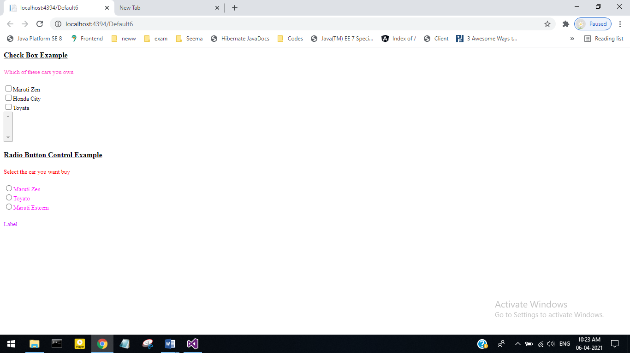

**2.After Clicking Check Box :-**

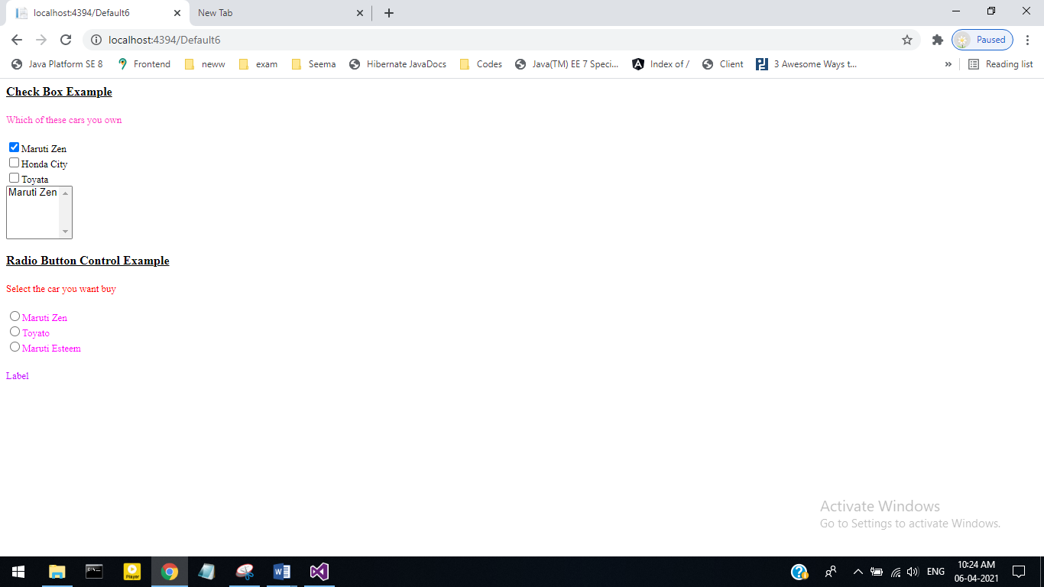

**3.After Clicking Radio Button :-**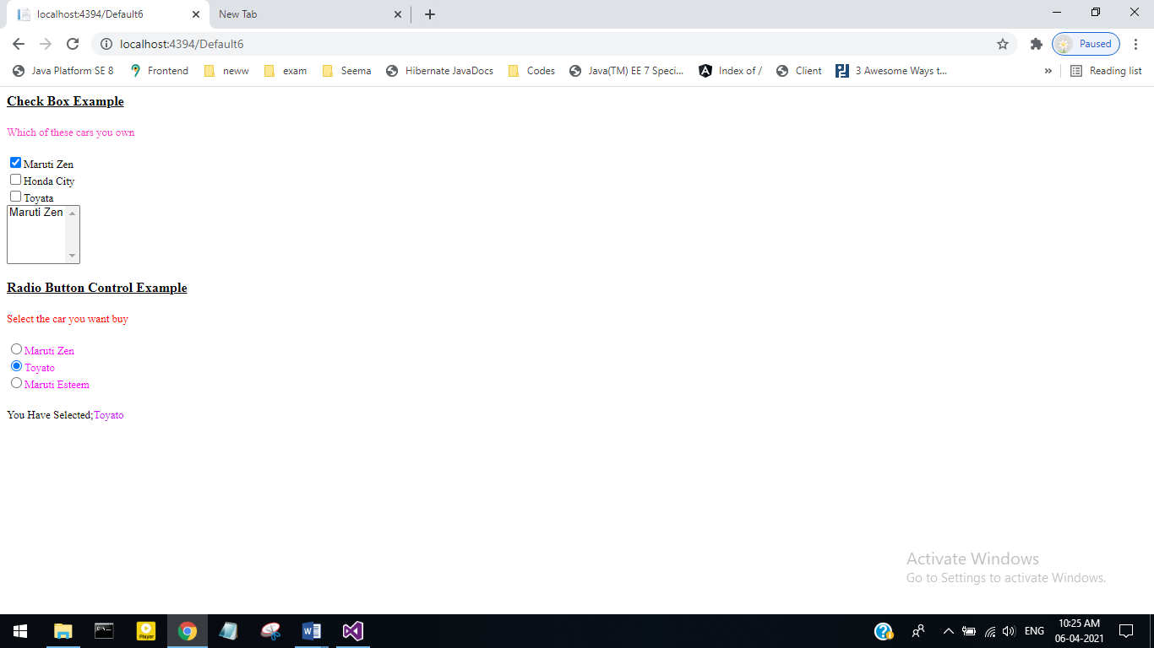

**ASSIGNMENT NO 5**

**Roll No 27**

**1) Write a program to demonstrate the required field validator.**

**Default.aspx**

<%@ Page Language="C#" AutoEventWireup="true" CodeFile="Default7.aspx.cs" Inherits="Default7" %>

<!DOCTYPE html>

<html xmlns="http://www.w3.org/1999/xhtml">

<head runat="server">

<title></title>

</head>

<body>

<form id="form1" runat="server">

<div>

<asp:TextBox ID="textBox1" runat="server"></asp:TextBox>

<asp:RequiredFieldValidator ID="RequiredFieldValidatorl" runat="server" ErrorMessage="Required!" ControlToValidate="TextBox1"></asp:RequiredFieldValidator>

<asp:Button ID="button1" runat="server" text="submit" CausesValidation="true" />

</div>

</form>

</body>

</html>

**Output:**

**1.Before submit**

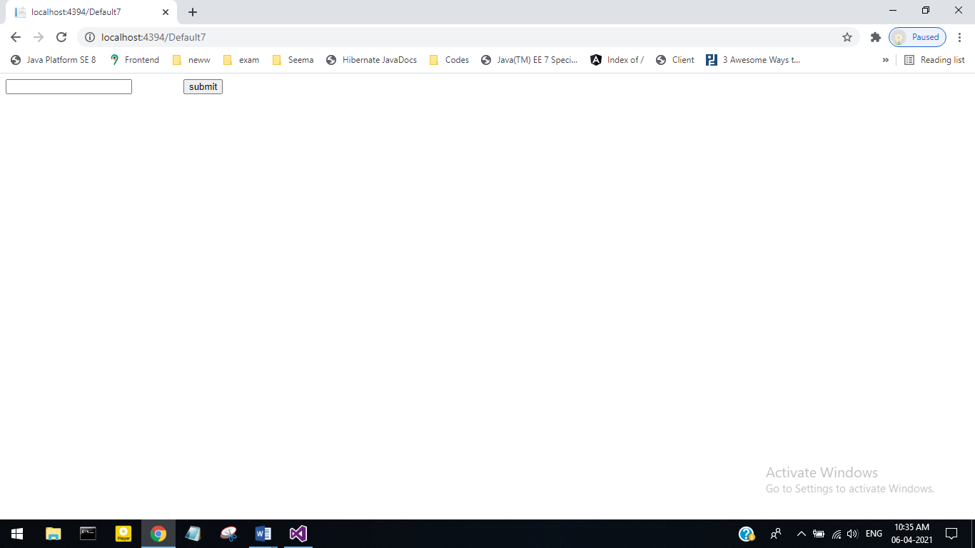

**2.Empty Submit**

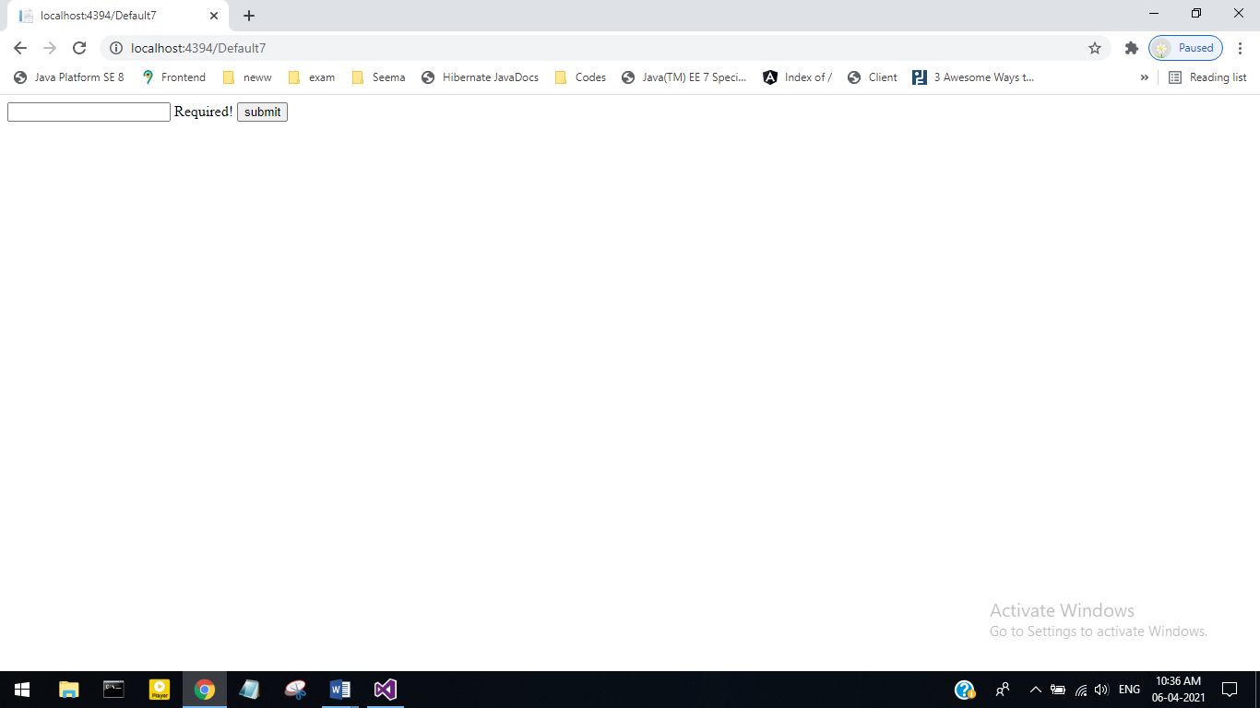

**3. Valid Submit**

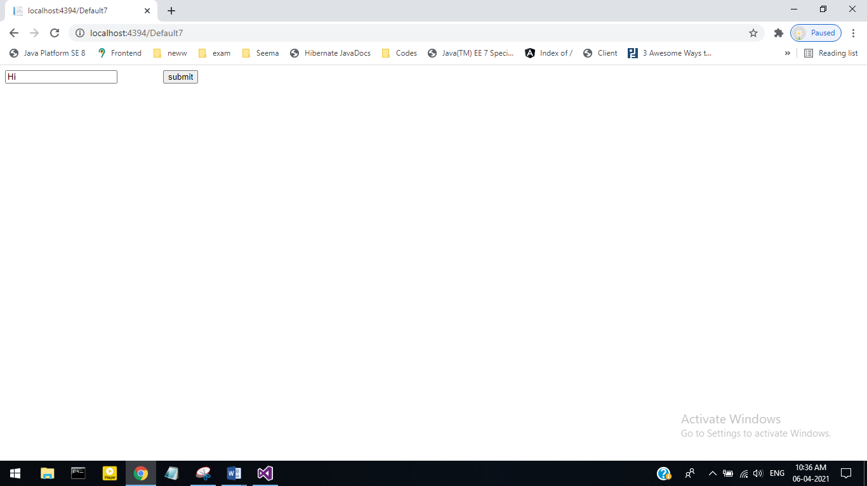

**Roll No 27**

**2) Write a program compare validator server.**

**Default.aspx**

<%@ Page Language="C#" AutoEventWireup="true" CodeFile="Default8.aspx.cs" Inherits="Default8" %>

<!DOCTYPE html>

<html xmlns="http://www.w3.org/1999/xhtml">

<head runat="server">

<title></title>

</head>

<body>

<form id="form1" runat="server">

<div>

<table>

<tr>

<td>

<asp:Label ID="Label2" runat="server" Text="confirm password"></asp:Label>

</td>

<td>

<asp:TextBox ID="TextBox2" TextMode="Password" runat="server"></asp:TextBox>

</td>

</tr>

<tr>

<td>

<asp:Label ID="Lable2" runat="server" Text="confirm password"></asp:Label>

</td>

<td>

<asp:TextBox ID="textbox3" TextMode="Password" runat="server"></asp:TextBox>

</td>

</tr>

<tr>

<td>

<asp:Button ID="button2" runat="server" Text="Login" />

</td>

</tr>

</table>

<asp:CompareValidator ID="compareValidatorl" runat="server"

ErrorMessage="passwords don't Match!" ControlToValidate="textBox3" ControlToCompare="textbox2"></asp:CompareValidator>

</div>

</form>

</body>

</html>

**Output:**

**1.Before submit-**

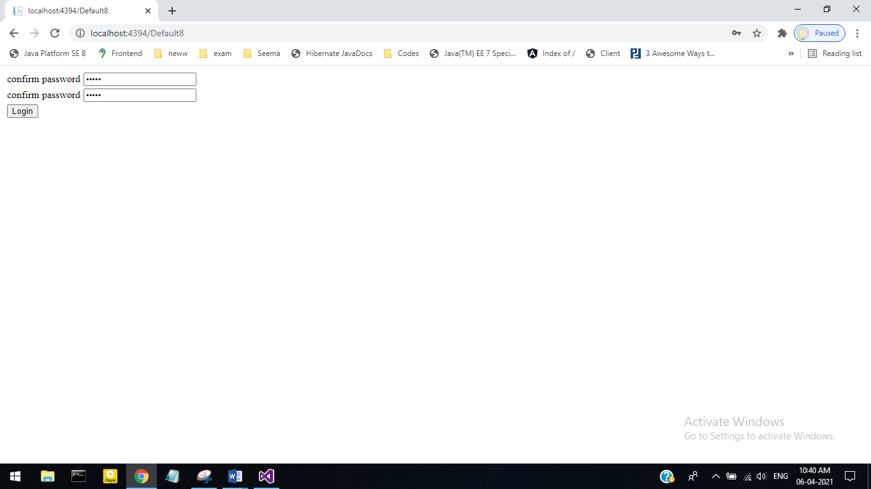

**2.Same Password-**

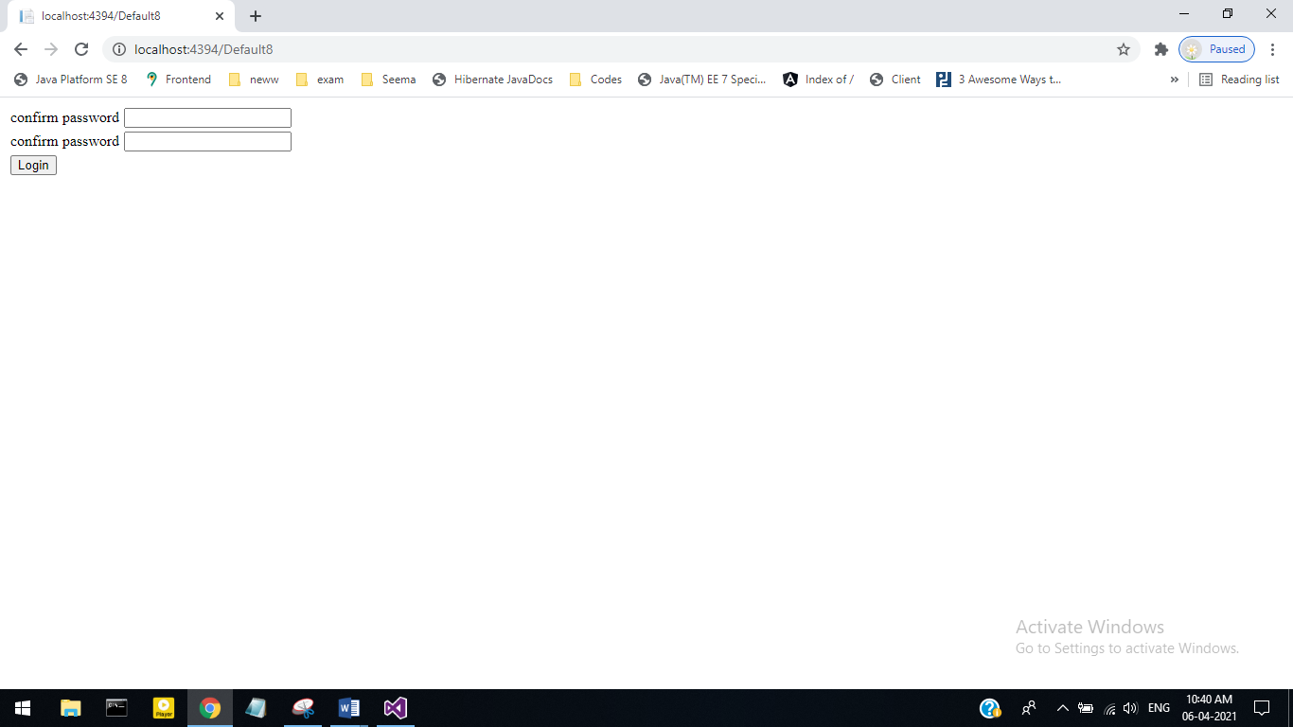

**3.Different password-**

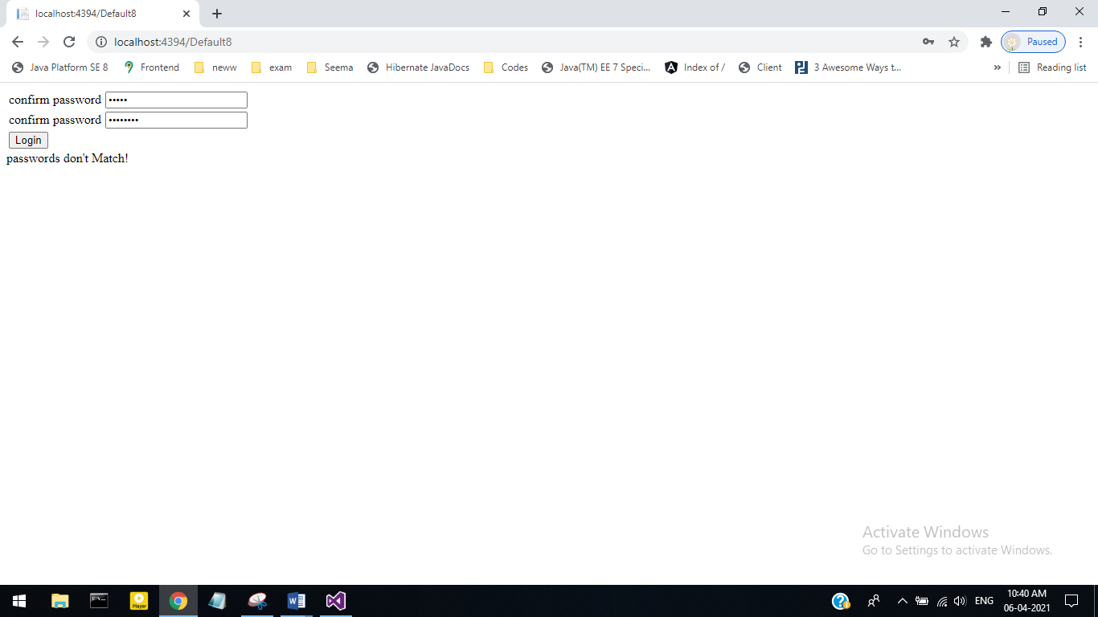

**Roll No 27**

**3) Write a program Range validator server control.**

**Default.aspx**

<%@ Page Language="C#" AutoEventWireup="true" CodeFile="Default9.aspx.cs" Inherits="Default9" %>

<!DOCTYPE html>

<html xmlns="http://www.w3.org/1999/xhtml">

<head runat="server">

<title></title>

</head>

<body>

<form id="form1" runat="server">

<div>

<asp:TextBox ID="RangeTextbox" runat="server"></asp:TextBox>

&nbsp;&nbsp;&nbsp;&nbsp;&nbsp;&nbsp;&nbsp;

<asp:RangeValidator ID="RangeValidator1" runat="server"

ErrorMessage="InValid Marks" ControlToValidate="rangetextbox"

type="Integer" MinimumValue="0" MaximumValue="80"></asp:RangeValidator>

<br />

<br />

<br />

<asp:Button ID="CheckRange" runat="server" text="Marks" />

</div>

</form>

</body>

</html>

**Output:**

**Before input-**

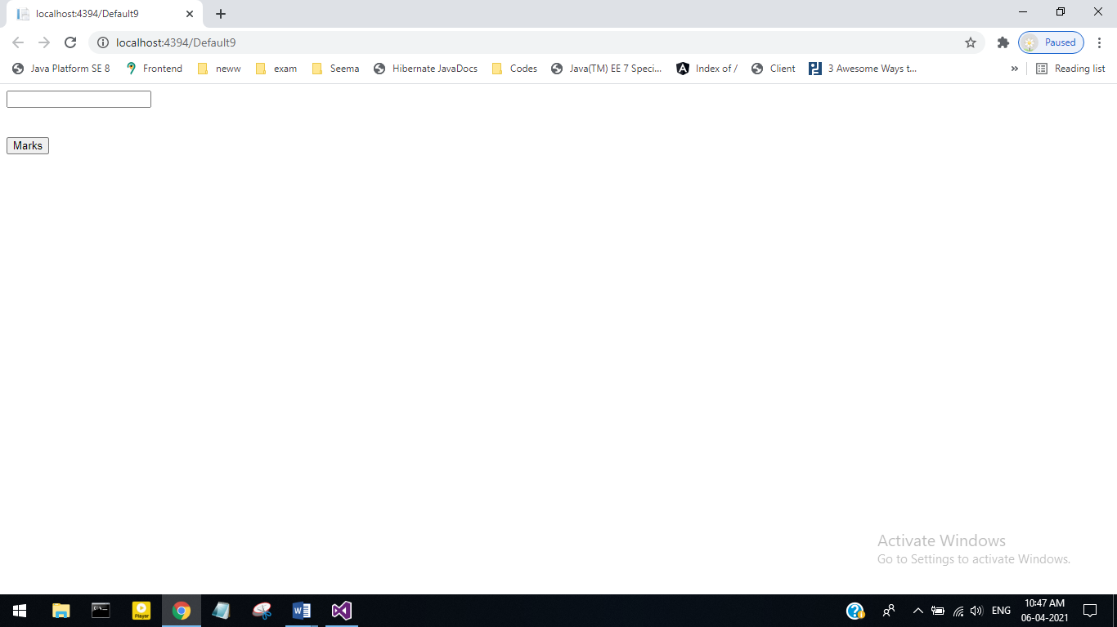

**Valid input-**

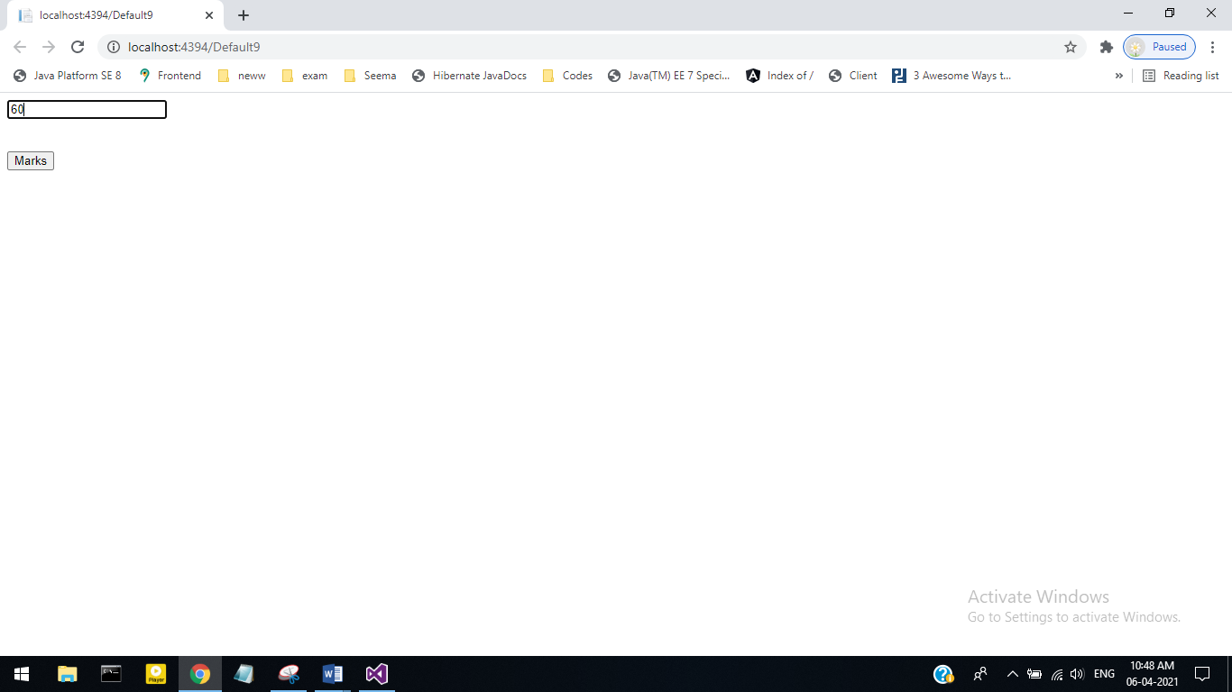

**Invalid input-**

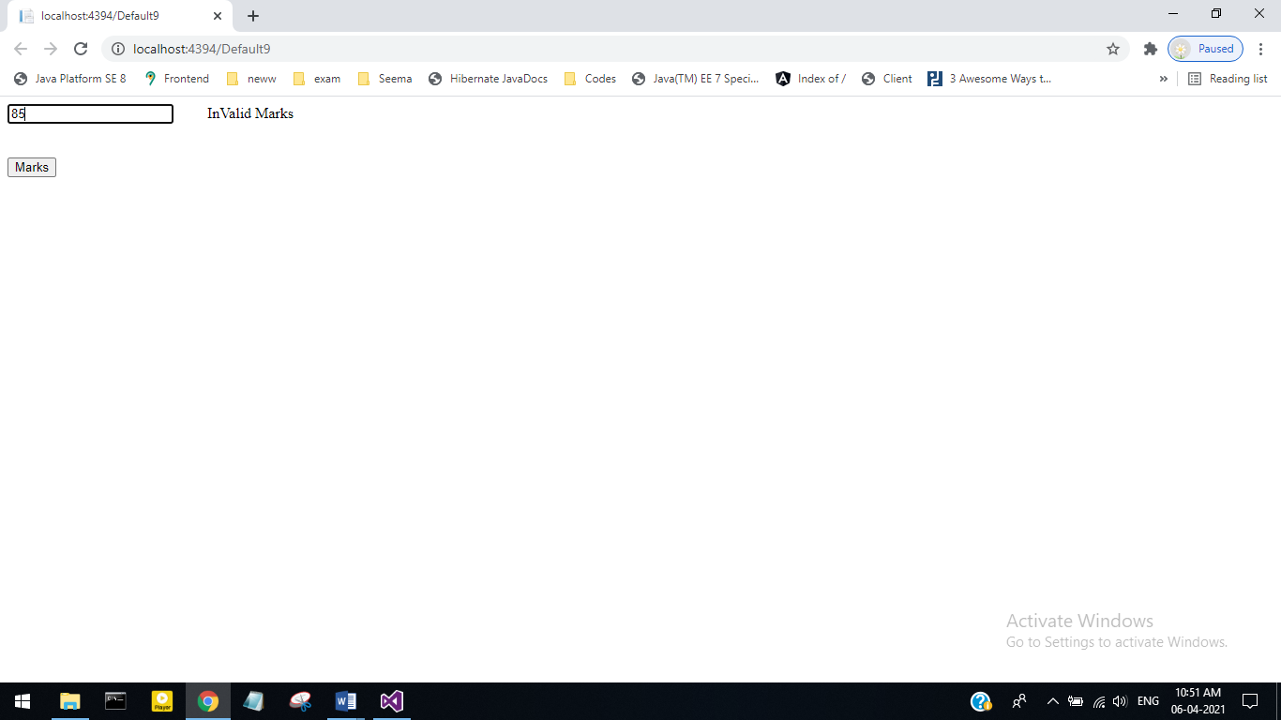

**Roll No 27**

**4) Write a program Regular expression validator server Control.**

**Default.aspx**

<asp:TextBox ID="TextBox4" runat="server"></asp:TextBox>

<asp:RegularExpressionValidator ID="RegularExpressionValidator1" ControlToValidate="Textbox4" runat="server" ErrorMessage="You must enter an email address" ValidationExpression="\w+([- +]\w+)*@\w+([-]\w+)*\.\w+([-]\w+)*"></asp:RegularExpressionValidator>

<br />

<br />

<asp:Button ID="Button3" runat="server" Text="Check Mail" />

**Output-**

**1.Correct Email ID**

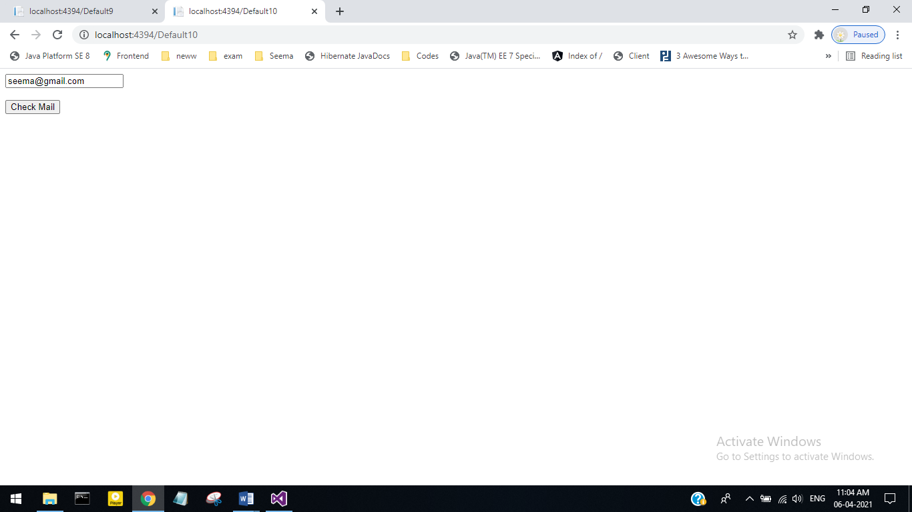

**2.Wrong Email ID**

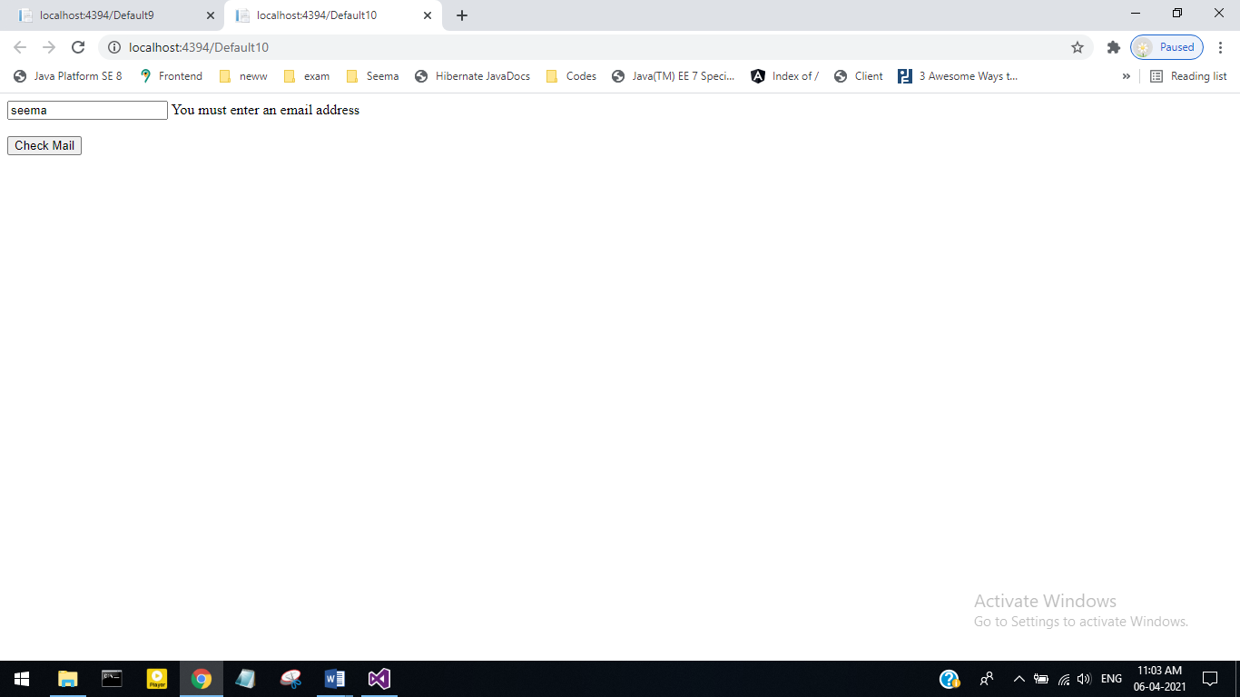

**Roll No 27**

**5) Write a program Custom validator server control.**

**Default.aspx**

<%@ Page Language="C#" AutoEventWireup="true" CodeFile="Default11.aspx.cs" Inherits="Default11" %>

<!DOCTYPE html>

<html xmlns="http://www.w3.org/1999/xhtml">

<head runat="server">

<title></title>

</head>

<body>

<form id="form1" runat="server">

<div>

<asp:Panel ID="Panel1" runat="server">

<asp:Label ID="Label1" runat="server" Text="Enter even number-"></asp:Label>

<asp:TextBox ID="TextBox1" runat="server"></asp:TextBox>

<asp:CustomValidator ID="CustomValidator1" runat="server"

ControlToValidate="TextBox1" ErrorMessage="Plz enter even number"

onservervalidate="CustomValidator1_ServerValidate"></asp:CustomValidator>

<br />

<asp:Button ID="Button1" runat="server" Text="Submit" />

</asp:Panel>

</div>

</form>

</body>

</html>

**Output:**

1. Entering Even number-

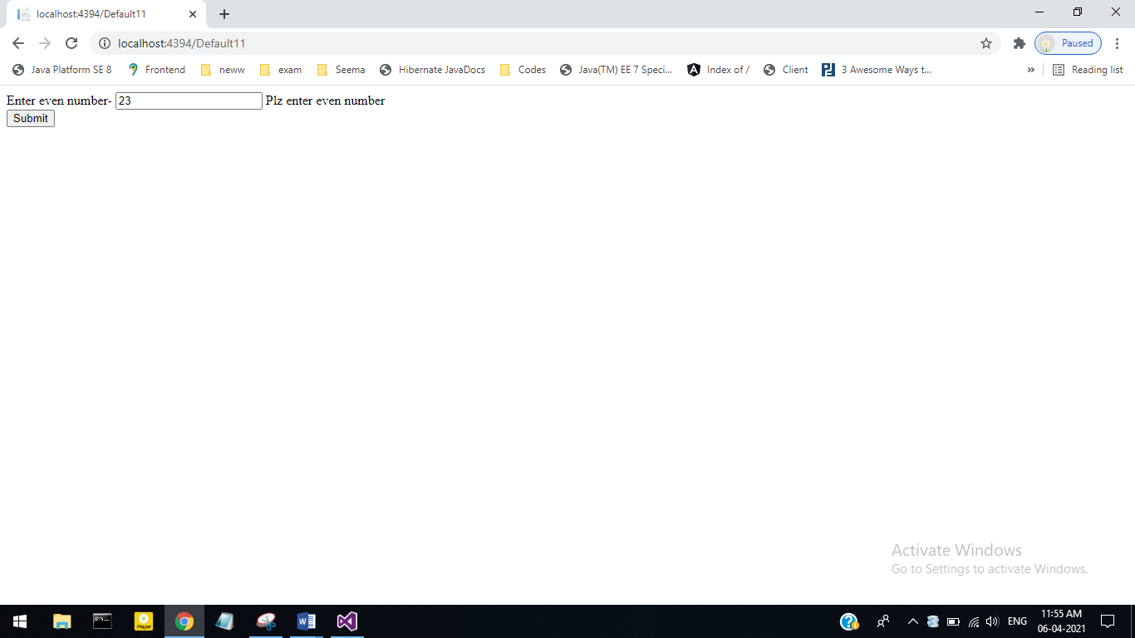

1. Entering Odd number-

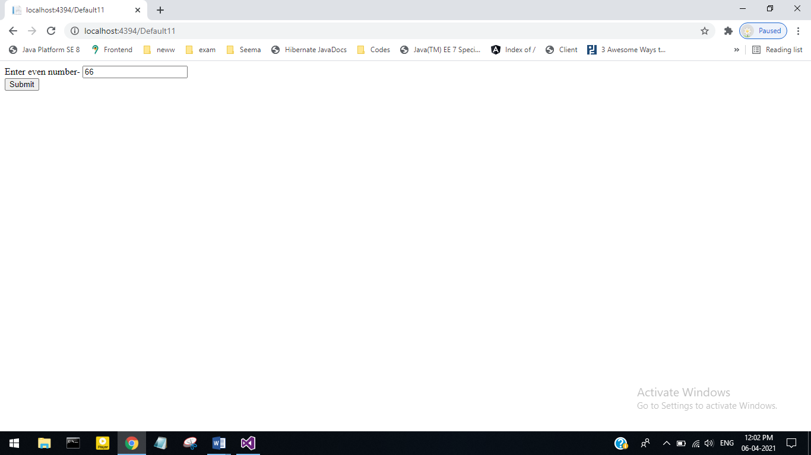

**ASSIGNMENT NO 6**

**Roll No 27**

**1) Write a program to demonstrate the view state, application state, session state.**

**Default.aspx**

<%@ Page Language="C#" AutoEventWireup="true" CodeFile="Default12.aspx.cs" Inherits="Default12" %>

<!DOCTYPE html>

<html xmlns="http://www.w3.org/1999/xhtml">

<head runat="server">

<title></title>

</head>

<body>

<form id="form1" runat="server">

<div>

<span style="text-decoration:underline">view state</span><br/>

Enter your name:

<asp:TextBox ID="txtName" runat="server" />

<br/>

&nbsp;&nbsp;&nbsp;&nbsp;&nbsp;&nbsp;&nbsp;&nbsp;&nbsp;&nbsp;&nbsp;&nbsp;&nbsp;&nbsp;&nbsp;&nbsp;&nbsp;&nbsp;

<br/>

&nbsp;&nbsp;&nbsp;&nbsp;&nbsp;&nbsp;&nbsp;&nbsp;&nbsp;&nbsp;&nbsp;&nbsp;&nbsp;&nbsp;&nbsp;&nbsp;&nbsp;&nbsp;

<asp:Button ID="btnSubmit" Text="submit" OnClick="btnSubmit_Click" runat="server" />

<br />

<asp:Label ID="Label1" runat="server" Text="Label"></asp:Label><br />

&nbsp;

<br />

<br />

<br />

<span style="Text-decoration: underline"><strong>Application State<br />

<br />

</strong></span>Number of Last visits:

<asp:Label ID="Label2" runat="server" Text="Label"></asp:Label><br />

<br />

<br />

<strong><span style="text-decoration:underline">Session state <br />

</span></strong>

<br />

<asp:Label ID="Label3" runat="server" Text="Label"></asp:Label><br />

</div>

</form>

</body>

</html>

**Default.aspx.cs**

using System;

using System.Collections.Generic;

using System.Linq;

using System.Web;

using System.Web.UI;

using System.Web.UI.WebControls;

public partial class Default12 : System.Web.UI.Page

{

protected void Page_Load(object sender, EventArgs e)

{

Application["visits"] = (int)Application["visits"] + 1;

Label2.Text = Application["visits"].ToString();

Label3.Text = (string)Session["mytext"];

}

protected void btnSubmit_Click(object sender, EventArgs e)

{

string txtvalue = txtName.Text;

ViewState.Add("item", txtvalue);

string item = (string)ViewState["item"];

Label1.Text = item;

}

}

**Global.asax**

<%@ Application Language="C#" %>

<%@ Import Namespace="WebSite3" %>

<%@ Import Namespace="System.Web.Optimization" %>

<%@ Import Namespace="System.Web.Routing" %>

<script runat="server">

void Application_Start(object sender, EventArgs e)

{

RouteConfig.RegisterRoutes(RouteTable.Routes);

BundleConfig.RegisterBundles(BundleTable.Bundles);

Application["visits"] = 0;

}

void Application_End(object sender, EventArgs e)

{

// Code that runs on application shutdown

}

void Application_Error(object sender, EventArgs e)

{

// Code that runs when an unhandled error occurs

}

void Session_Start(object sender, EventArgs e)

{

Session["mytext"] = "I am the user!!";

}

void Session_End(object sender, EventArgs e)

{

// Code that runs when a session ends.

// Note: The Session_End event is raised only when the sessionstate mode

// is set to InProc in the Web.config file. If session mode is set to StateServer

// or SQLServer, the event is not raised.

}

</script>

**Output:**

**1. Starting Page:**

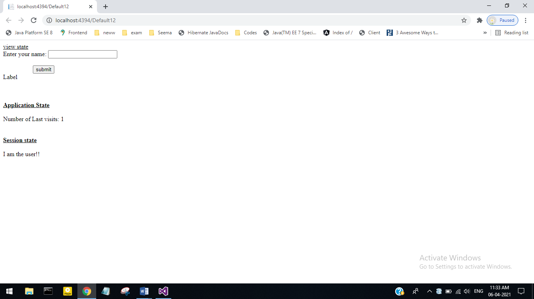

**2. Visited User :**

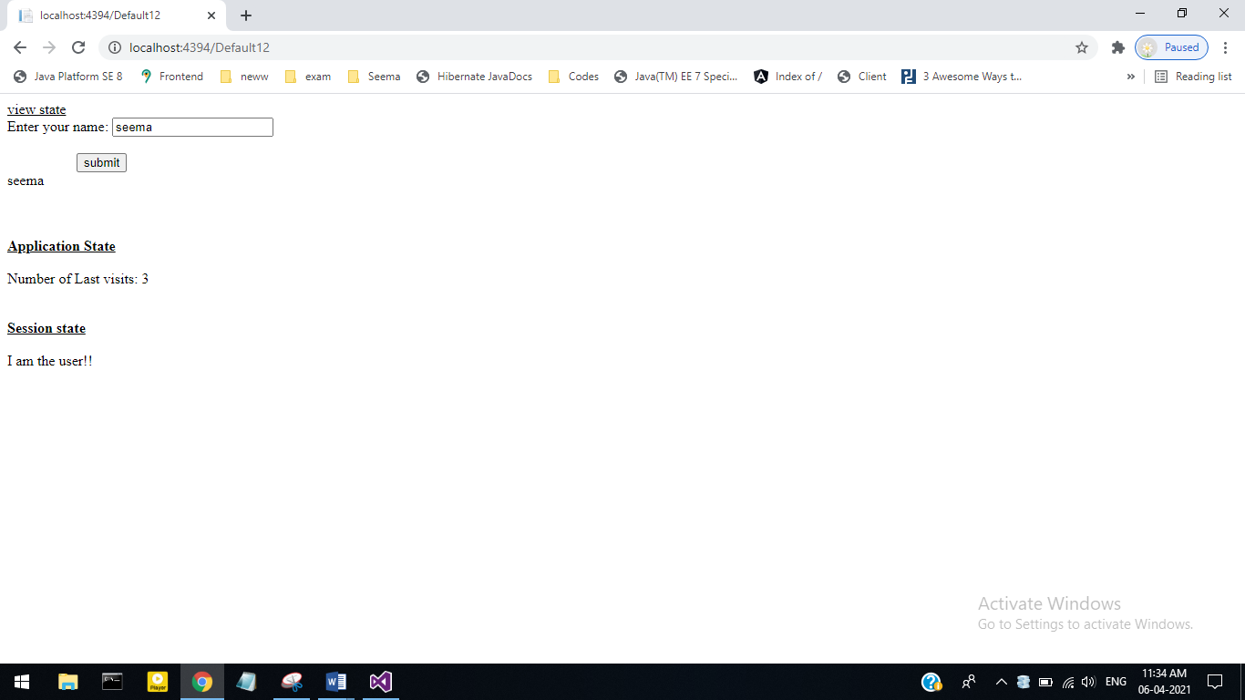

**Roll No 27**

**2) Write a program to demonstrate the simple interest.**

**Default.aspx**

<%@ Page Language="C#" AutoEventWireup="true" CodeFile="Default13.aspx.cs" Inherits="Default13" %>

<!DOCTYPE html>

<html xmlns="http://www.w3.org/1999/xhtml">

<head runat="server">

<title></title>

</head>

<body>

<form id="form1" runat="server">

<div>

<asp:Label ID="Label1" runat="server" Text="Enter Amount:"></asp:Label>

<asp:TextBox ID="TextBox1" runat="server" ></asp:TextBox>

<br />

<asp:Label ID="Label2" runat="server" Text="Enter Rate:"></asp:Label>

<asp:TextBox ID="TextBox2" runat="server"></asp:TextBox>

<br />

<asp:Label ID="Label3" runat="server" Text="Enter Year:"></asp:Label>

<asp:TextBox ID="TextBox3" runat="server"></asp:TextBox>

<br />

<br />

<asp:Button ID="Button1" runat="server" Text="Simple Interest" OnClick="ButtonClick" />

<br />

<br />

<asp:Label ID="Label5" runat="server" Text="Simple Interest"></asp:Label>

<asp:TextBox ID="TextBox5" runat="server"></asp:TextBox>

</div>

</form>

</body>

</html>

**Default.aspx.cs**

using System;

using System.Collections.Generic;

using System.Linq;

using System.Web;

using System.Web.UI;

using System.Web.UI.WebControls;

public partial class Default13 : System.Web.UI.Page

{

protected void Page_Load(object sender, EventArgs e)

{

}

protected void ButtonClick(object sender, EventArgs e)

{

int a = Convert.ToInt32(TextBox1.Text);

int r = Convert.ToInt32(TextBox2.Text);

int n = Convert.ToInt32(TextBox3.Text);

int si = ((a * r * n) / 100);

TextBox5.Text = si.ToString();

}

}

**Output:**

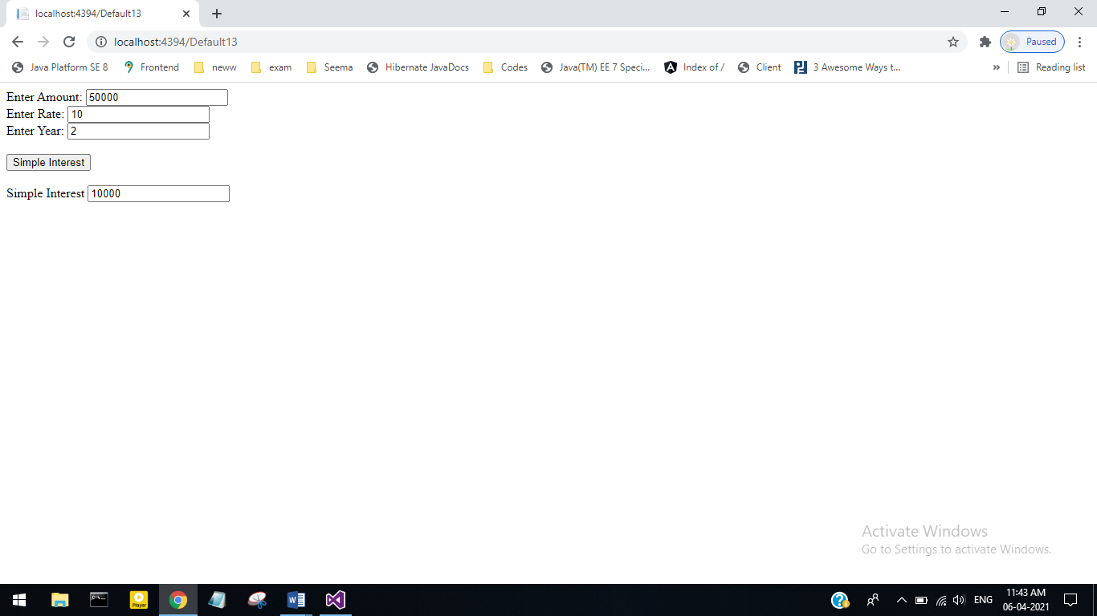

**Roll No 27**

**3) Write a program to display the date & time using the Global.asax file.**

**Default.aspx**

<%@ Page Language="C#" AutoEventWireup="true" CodeFile="Default14.aspx.cs" Inherits="Default14" %>

<!DOCTYPE html>

<html xmlns="http://www.w3.org/1999/xhtml">

<head runat="server">

<title></title>

</head>

<body>

<form id="form1" runat="server">

<div>

<asp:Label ID="Label2" runat="server" Text="This page exicuted on:"></asp:Label>

<asp:Label ID="Label1" runat="server" Text="Label"></asp:Label>

</div>

</form>

</body>

</html>

**Default.aspx.cs**

using System;

using System.Collections.Generic;

using System.Linq;

using System.Web;

using System.Web.UI;

using System.Web.UI.WebControls;

public partial class Default14 : System.Web.UI.Page

{

protected void Page_Load(object sender, EventArgs e)

{

Label1.Text = DateTime.Now.ToString();

}

}

**Output:**